|  |  |  |  |  |  |  |
| --- | --- | --- | --- | --- | --- | --- |
| Document ID | | | | | | |
| Document Title | | | Installation and Calibration Report Caisson {{ CaissonNumber }} | | | |
| Employer Document Reference | | | {{ MCRDocumentReference }} | | | |
| Employer | | | Elia Asset NV/SA | | | |
| Project Name | | | EPCI Energy Island for MOG2 Project | | | |
| Scan QR code to check if this is the latest revision   |  | | --- | |  |   Revision Status | | | | | | |
| Rev. | Date | Description | | Prepared | Checked | Approved |
| 00 | Click or tap to enter a date. | Document creation date | | Initials |  |  |
| 01 | Click or tap to enter a date. | First revision for Caisson {{ CaissonNumber }} | |  |  |  |
|  |  |  | |  |  |  |

Table of Contents

1. Introduction 4

1.1 Project description 4

1.2 Scope of Document 4

1.3 Scope of Work 4

2. References 5

2.1 Internal References 5

2.2 Elia References 5

3. Abbreviations 5

4. Survey System Setup 6

4.1 Caisson – schematic Overview 6

4.2 CCSC Survey System – Schematic Overview 6

4.3 Equipment installed on Caisson {{ CaissonNumber }} 7

4.4 Software used during installation and calibrations. 7

4.5 Personnel. 8

5. Survey System Calibrations and Verifications 8

5.1 Geodetic Parameter Check 8

5.2 Dimensional Control Measurements 10

5.3 Conversion of offsets to the QINSy Reference Frame 11

5.4 Conversion of offsets to the SBG Reference Frame 12

5.5 Qinsy Shape Verification 13

5.6 Heading reference systems Calibration & Verification (GNSS) 13

5.6.1 Calibration 13

5.7 Attitude sensor systems Calibrations & Verification 16

5.7.1 Calibration 16

5.7.2 MRU Verification 16

5.7.3 Pitch & Roll conventions used. 18

5.8 Position verifications 19

5.9 CCSC Survey Systems health check 19

6. Annexes 20

6.1 Annex 1: Geodetic Parameter Check 20

6.2 Annex 2: Dimension Control POI 21

6.3 Annex 3: Gyro Verification Reports 22

6.3.1 Gyro 1 Verification. 22

6.3.2 Gyro 2 Verification 23

6.4 Annex 4: MRU Verification Reports 24

6.4.1 MRU 1 Verification 24

6.4.2 MRU 2 Verification 25

6.5 Annex 5: Caisson Position Verification Reports 26

6.5.1 Position Verification CCSC {{ IP_1 }} Refmark 1 26

6.5.2 Position Verification CCSC {{ IP_1 }} Refmark 4 27

6.5.3 Position Verification CCSC {{ IP_2 }} Refmark 1 28

6.5.4 Position Verification CCSC {{ IP_2 }} Refmark 4 29

6.6 Annex 6: GNSS Health 30

6.7 Annex 7: QINSy DB Template 31

List of Figures

Figure 1: Caisson – POI Overview. 6

Figure 2: CCSC Survey System – Overview. 6

Figure 3: Geodetic Parameter Check. 9

Figure 4: Caisson Reference Frame. 10

Figure 5: QINSy Reference Frame. 11

Figure 6: SBG Reference Frame 12

Figure 7: Qinsy Shape Verification 13

Figure 8: Heading C-O 14

Figure 9: MRU YAW 16

Figure 10: MRU Misalignments 17

Figure 11: Conventions used in QINSy 18

Figure 12: Conventions used in MGC Ekinox configuration Software 18

List of Tables

Table 1 - Referencing to internal documents 5

Table 2 - Referencing to Elia documents 5

Table 3 - Abbreviations 5

Table 4 - Equipment installed 7

Table 5 - Software used 7

Table 6 – Personnel 8

Table 7: Caisson Reference Frame. 10

Table 8: QINSy Reference Frame. 11

Table 9: SBG Reference frame. 12

Table 10: Heading C-O CCSC IP19 14

Table 11: Heading C-O CCSC IP20 14

Table 12: Yaw Misalignment of Baseplate 16

Table 13: C-O Results MRU Calibration 17

1. Introduction
   1. Project description

A detailed Project Description can be found in the General Project Information [1].

* 1. Scope of Document

The purpose of this document is to present a summary of the survey operations, installations and calibrations acquired for Caisson {{ CaissonNumber }}; prior to the commencement of the installation of the caisson associated with the EPCI Energy Island for MOG2 Project.

The calibrations and verifications have been carried out by the TM EDISON Survey Department in accordance with the specifications described in the General Survey Method Statement [4], whilst the Caisson was being constructed/prepared at Vlissingen, the Netherlands.

* 1. Scope of Work

TM EDISON provided a comprehensive suite of positioning and survey systems to meet the requirements for the survey, positioning, and installation operations of Caisson {{ CaissonNumber }}. The scope of work as completed by TME during the installation and calibration period comprised the following:

* Survey System installation
* Geodetic Verification
* Dimensional Control measurements (Caisson Reference Frame)
* Conversion of offsets to QINSy & SBG Reference Frames
* QINSy Shape Verification
* Heading reference systems Calibration & Verification
* Attitude sensor systems Calibrations & Verification
* Position Verifications
* CCSC Survey Systems health check

1. References
   1. Internal References

|  |  |  |
| --- | --- | --- |
| **Ref.** | **Document Number** | **Document title** |
|  | MOG2-EDI-ISZ-PMZ-MGP-0011 | General Project Information |
|  | MOG2-EDI-WPZ-MSV-PRO-0001 | Geodetic setup |
|  | MOG2-EDI-ISP-CIV-REP-0006 | Detailed design - Caisson and wave wall (overall stability) |
|  | MOG2-EDI-ISZ-MSV-PRO-0001 | General Survey Method Statement |
|  | MOG2-EDI-ISP-MSV-PRO-0001 | Caisson Installation Survey Procedure |
|  | {{ DIMCONDocumentReference }} | Offset Measurement Report Caisson {{ CaissonNumber }} |

Table 1 - Referencing to internal documents

* 1. Elia References

|  |  |  |
| --- | --- | --- |
| **Ref.** | **Document Number** | **Document title** |
|  | MOG2-IMD-SZZIN-00001_v02 | 3.B.6_Survey Requirements |
|  | MOG2-ELI-SZZIN-00002_v01 | 3.B.7 - Survey Technical Requirements |

Table 2 - Referencing to Elia documents

1. Abbreviations

|  |  |
| --- | --- |
| Abbreviation | Definition |
| c-o | Calculated minus Observed |
| CSC | Compact Survey Case |
| CCSC | Caisson Compact Survey Case |
| GNSS | Global Navigation Satellite System |
| MRU | Motion Reference Unit |
| NTRIP | Network Transport of RTCM via Internet Protocol |
| POI | Point Of Interest |
| RTCM | Radio Technical Commission for Maritime Services |
| RTK | Real Time Kinematic |
| UHF | Ultra-High Frequency |
| OCC | Operation Control Container |

Table 3 - Abbreviations

1. Survey System Setup
   1. Caisson – schematic Overview

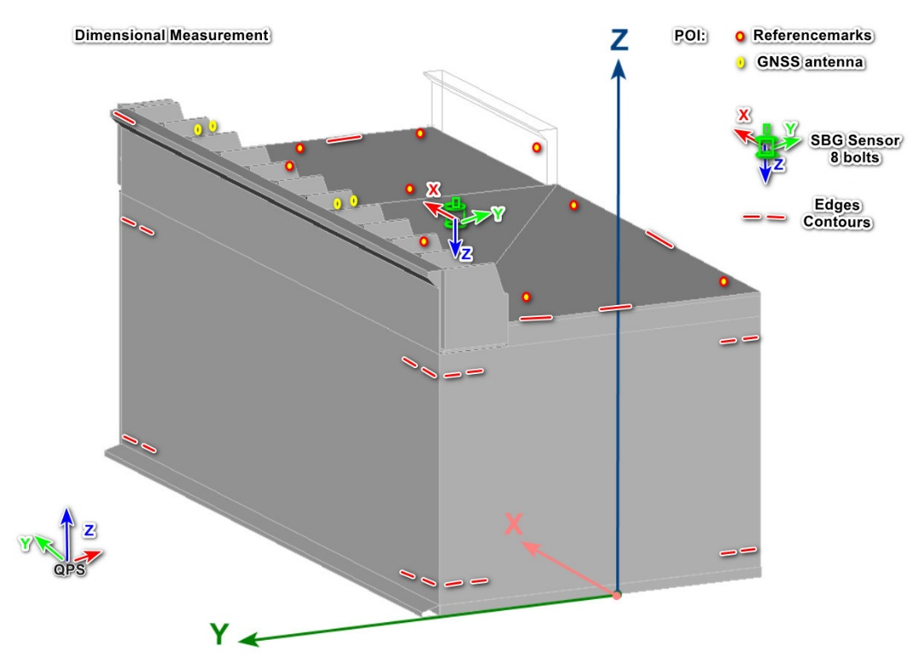

Portside

Starboard

Aft

Fore

Figure 1: Caisson – POI Overview.

Caisson {{ CaissonNumber }} is equipped with two CCSC survey systems (Caisson Compact Survey Case), each containing an SBG Ekinox IMU sensor with an integrated Septentrio GNSS receiver. These systems provide two independent position and motion data streams for the caisson {{ CaissonNumber }}. The data is transmitted via Wi-Fi to the visualization and data acquisition software used on tugboats and the offshore coordination centre (OCC).

* 1. CCSC Survey System – Schematic Overview

Figure 2: CCSC Survey System – Overview.

* 1. Equipment installed on Caisson {{ CaissonNumber }}

|  |  |  |
| --- | --- | --- |
| CCSC IP{{ IP_1 }} | SBG- Ekinox | s/n {{ SN_SBG1 }} |
| Septentrio | s/n {{ SN_Septentrio1 }} |
| Antenna A1 | s/n {{ SN_Ant1 }} |
| Antenna A2 | s/n {{ SN_Ant2 }} |
| CCSC IP{{ IP_2 }} | SBG- Ekinox | s/n {{ SN_SBG2 }} |
| Septentrio | s/n {{ SN_Septentrio2 }} |
| Antenna A3 | s/n {{ SN_Ant3 }} |
| Antenna A4 | s/n {{ SN_Ant4 }} |

Table 4 - Equipment installed

* 1. Software used during installation and calibrations.

|  |  |  |
| --- | --- | --- |
| Software | Use | Version |
| QPS QINSy | Online Visualisation, Data Acquisition and QC | 9.7.5.1784 (Build 2025.01.20.1) |
| Bricsys BricsCAD | Computer Assisted Design for simple offline tasks | V21 |
| Microsoft Office | Reporting & Automated sheets | MS Office 365 |
| Trimble Business Centre | Transformation DGNSS & Topo data | TBC 5.10 |

Table 5 - Software used

* 1. Personnel.

|  |  |  |
| --- | --- | --- |
| Name | Function | Period |
| Gertjan Bisschop | Survey Manager | 01/07/24 – 14/09/2025 |
| Bart Engelbeen-Himpe | Installations, calibrations, verifications and reporting | 01/07/24 – 14/09/2025 |
| Arne Deruyck | Installations, calibrations, verifications | 01/01/25 – 18/08/2025 |
| Tim Syryn | Installations, calibrations, verifications | 01/07/24 – 14/09/2025 |
|  |  |  |

Table 6 – Personnel

1. Survey System Calibrations and Verifications

Prior to the start of the project, calibration and verification checks were conducted to ensure that all sensors and processing equipment were functioning correctly and operating within the manufacturer’s specifications. These checks were performed to meet the employer’s requirements for survey and positioning operations on board the installation vessels and caissons.

* 1. Geodetic Parameter Check

All the offshore survey works will be done in the WGS84 UTM31N reference system. As a vertical reference the BeLAT model will be used.

For detailed information about the used geodetics, a reference is made to the documents Geodetic Setup [2] and General Survey Method Statement [4].

Prior to the Calibrations, Verification and Checks for Caisson {{ CaissonNumber }}, a Geodetic Parameter Check was done with the visualisation & data acquisition software package as used at OCC (Operation Control Container).

The co-ordinate transformation example as in document *Geodetic setup* [2] was used to verify the geodetic configuration in the survey online navigation software.

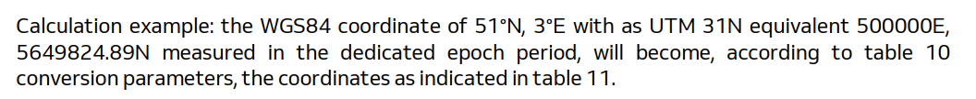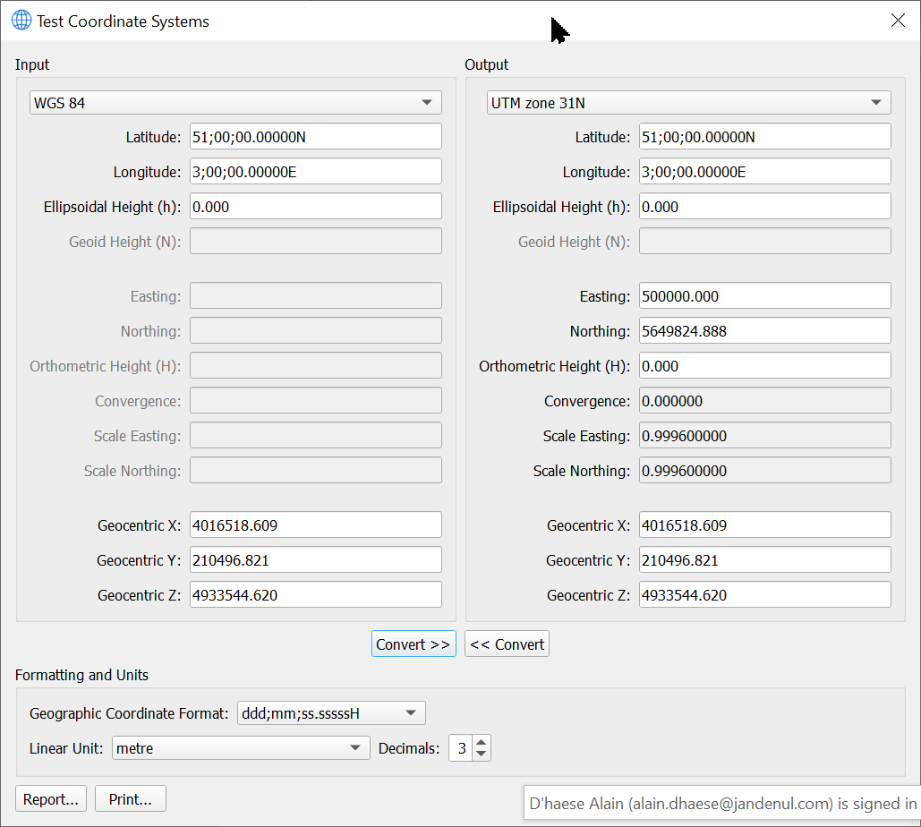

Figure 3: Geodetic Parameter Check.

See also Annex 1: Geodetic Parameter Check for the full report.

* 1. Dimensional Control Measurements

The TM EDISON survey team measured the offsets of all POI during and after the construction of the caisson, as well as after the final installation of all survey equipment.

All results (X, Y, Z) are referenced within the caisson reference frame.

An overview of all POI can be found in Annex 2:.

The Caisson Reference Frame is defined as below:

Table 7: Caisson Reference Frame.

|  |  |  |
| --- | --- | --- |
| Coordinate | Origine at | Positive Direction |
| **X** | Aft perpendicular | Towards FWD |
| **Y** | Centre Line (CL) | Towards Portside (secondary Seawall) |
| **Z** | Baseline (or keel) (BL) | Upwards |

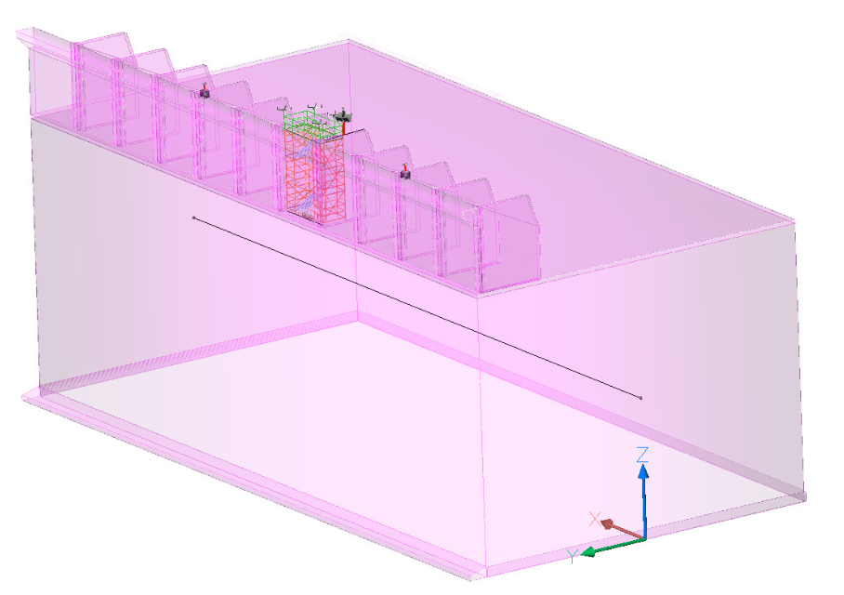

Portside

Starboard

Aft

Fore

Figure 4: Caisson Reference Frame.

A detailed description of these measurements can be found in document Offset Measurement Report Caisson {{ CaissonNumber }} [6].

* 1. Conversion of offsets to the QINSy Reference Frame

All offsets entered the visualisation software are in the QINSy Reference Frame.

An overview of the conversion of all POI can be found in Annex 2:.

The QINSy Reference Frame is defined as below:

Table 8: QINSy Reference Frame.

|  |  |  |
| --- | --- | --- |
| Coordinate | Origine at | Positive Direction |
| **X** | Aft perpendicular | Towards Starboard side |
| **Y** | Centre Line (CL) | Towards FWD |
| **Z** | Baseline (or keel) (BL) | Upwards |

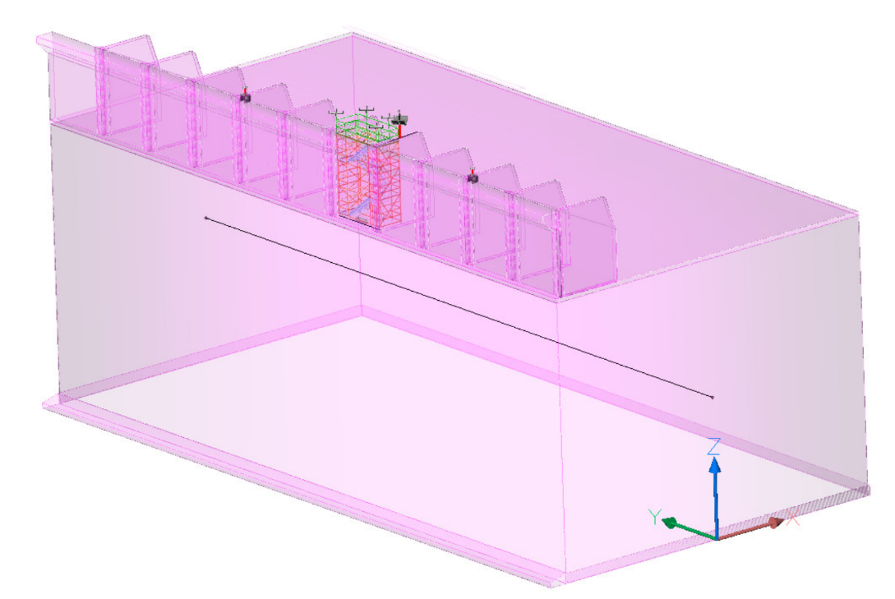

Portside

Starboard

Aft

Fore

Figure 5: QINSy Reference Frame.

* 1. Conversion of offsets to the SBG Reference Frame

All offsets entered the SBG configuration tool software are in the SBG Reference Frame.

An overview of the conversion of all POI, used by SBG, can be found in Annex 2:.

The SBG Reference Frame is defined as below:

Table 9: SBG Reference frame.

|  |  |  |
| --- | --- | --- |
| Coordinate | Origine at | Positive Direction |
| **X** | Cover Target | Towards FWD |
| **Y** | Cover Target | Towards Starboard side |
| **Z** | Cover Target | Downwards |

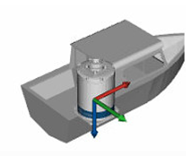

Figure 6: SBG Reference Frame

* 1. Qinsy Shape Verification

A selection of total station measurements was superimposed onto the Qinsy model shapes to verify that the Qinsy object shape accurately represents the as-built caisson {{ CaissonNumber }}.

Screenshots of the TOP, AFT and SIDE View Shape Verification:

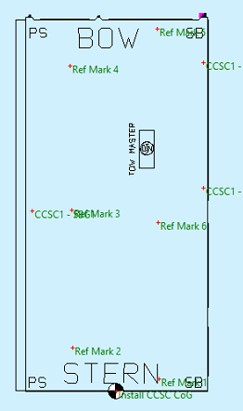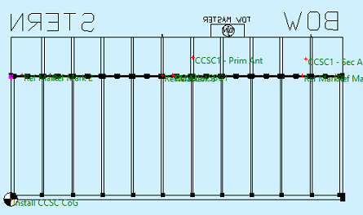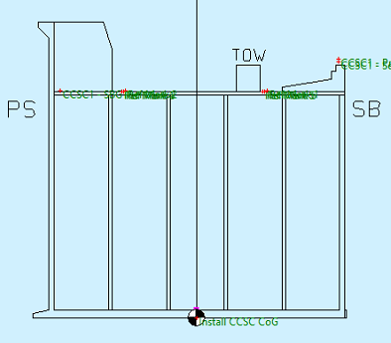

Figure 7: Qinsy Shape Verification

* 1. Heading reference systems Calibration & Verification (GNSS)

The GNSS Heading, calculated by the Septentrio inside the CCSC, is used as Heading Reference System for Caisson {{ CaissonNumber }}.

* + 1. Calibration

The initial misalignment (C-O) can be calculated, starting from the Antenna Offsets as measured in the Caisson Reference system. This theoretical is only to be considered as a 'general initial alignment of the Heading to minimise the final C-O results'.

**X**

GNSS antenna AUX

C-O

GNSS antenna MAIN

Figure 8: Heading C-O

|  |  |  |  |  |
| --- | --- | --- | --- | --- |
| CCSC IP{{ IP_1 }} | X | Y | Z | C-O |
| Antenna A1 Main | {{ GNSS01_A1_antenna_mount_base_X }} | {{ GNSS01_A1_antenna_mount_base_Y }} | {{ GNSS01_A1_antenna_mount_base_Z }} | XX |
| Antenna A2 Aux | {{ GNSS02_A2_antenna_mount_base_X }} | {{ GNSS02_A2_antenna_mount_base_Y }} | {{ GNSS02_A2_antenna_mount_base_Z }} |

Table 10: Heading C-O CCSC IP{{ IP_1 }}

|  |  |  |  |  |
| --- | --- | --- | --- | --- |
| CCSC IP{{ IP_2 }} | X | Y | Z | C-O |
| Antenna A3 Main | {{ GNSS03_A3_antenna_mount_base_X }} | {{ GNSS03_A3_antenna_mount_base_Y }} | {{ GNSS03_A3_antenna_mount_base_Z }} | XX |
| Antenna A4 Aux | {{ GNSS04_A4_antenna_mount_base_X }} | {{ GNSS04_A4_antenna_mount_base_Y }} | {{ GNSS04_A4_antenna_mount_base_Z }} |

Table 11: Heading C-O CCSC IP{{ IP_2 }}

After applying the initial C-O values, a heading verification was conducted to determine the final values.

To verify the heading alignment of the survey equipment, the reference marks were measured using the reference equipment in grid coordinates. These measurements were then compared with the corresponding reference mark positions in the caisson coordinate system. The transformation between the two coordinate frames was computed using singular value decomposition to derive the optimal rotation matrix, from which the heading alignment of the caisson was extracted by converting the matrix into Euler angles.

The calculated heading was then compared to the gyro heading output, where C-O values had already been applied. This comparison verified the accuracy of the existing C-O values and ensured that the gyro heading output was correctly aligned with the project coordinate system, enabling precise offshore positioning.

The heading verification results were applied as next:

* The final C-O value for CCSC IP{{ IP_1 }} unit was calculated as -0.0004. The C-O value has **not** been applied in the Qinsy software as the unit performs within its allowed accurancy range. The unit is now validated for use as the heading reference for caisson {{ CaissonNumber }}.
* The final C-O value for CCSC IP{{ IP_2 }} unit was calculated as 0.0008. The C-O value has **not** been applied in the Qinsy software as the unit performs within its allowed accurancy range. The unit is now validated for use as the heading reference for caisson {{ CaissonNumber }}.

The results of the Gyro Verification reports are illustrated within Annex 3: Gyro Verification Reports.

* 1. Attitude sensor systems Calibrations & Verification
     1. Calibration

To avoid any crossover from Pitch to Roll (and Roll to Pitch) the YAW (misalignment of sensor with the caisson’s X-axis) was calculated and entered directly within in the MRU sensors.

**X**

Y1

YAW

Y2

Base Plate

Ruler

Figure 9: MRU YAW

|  |  |  |  |  |
| --- | --- | --- | --- | --- |
| CCSC IP{{ IP_1 }} & IP{{ IP_2 }} | X | Y | Z | YAW |
| Y1 | {{ MRU_Ekinox_2_Cover_target_X }} | {{ MRU_Ekinox_2_Cover_target_Y }} | {{ MRU_Ekinox_2_Cover_target_Z }} | xx |
| Y2 | {{ MRU_Ekinox_1_Cover_target_X }} | {{ MRU_Ekinox_1_Cover_target_Y }} | {{ MRU_Ekinox_1_Cover_target_Z }} |

Table 12: Yaw Misalignment of Baseplate

* + 1. MRU Verification

After the YAW was applied, inside the units, and both MRU units were initialised, we performed an MRU verification to calculate the C-O for Pitch and Roll.

To determine the MRU alignment and the C-O for pitch and roll, a calibration procedure was carried out using measured reference marks on the caisson and their corresponding values in the local coordinate frame.

The reference marks were first surveyed using a Total Station, ensuring precise measurements of easting, northing, and height. These measurements were then compared against the predefined local caisson coordinates to establish the actual installation alignment.

A singular value decomposition transformation was applied to compute the optimal rotation matrix aligning the two coordinate systems. The resulting Euler angles extracted from this matrix provided the Pitch and Roll misalignments, forming the basis for determining the C-O values. Any reference marks with residuals exceeding 0.03m were excluded to ensure calibration accuracy.

Figure 10: MRU Misalignments

|  |  |  |  |
| --- | --- | --- | --- |
| Values as entered inside the units: | Misalignment Roll | Misalignment Pitch | Yaw |
| CCSC IP{{ IP_1 }} | {{ Roll_IP1 }} | {{ Pitch_IP1 }} | {{ Yaw_IP1 }} |
| CCSC IP{{ IP_2 }} | {{ Roll_IP2 }} | {{ Pitch_IP2 }} | {{ Yaw_IP2 }} |

Table 13: C-O Results MRU Calibration

The results of the MRU Verification reports are illustrated within Annex 6.4

* + 1. Pitch & Roll conventions used.

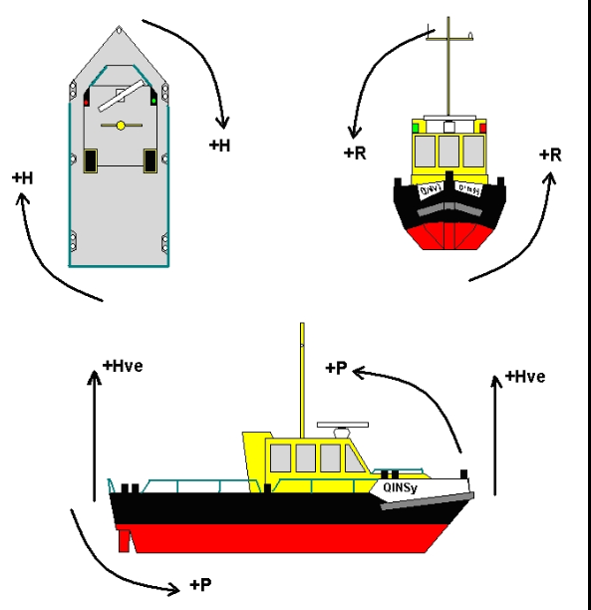

QINSY Reference Frame

Figure 11: Conventions used in QINSy

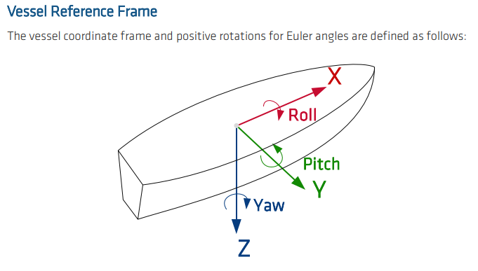

MGC Ekinox Reference Frame

Figure 12: Conventions used in MGC Ekinox configuration Software

* 1. Position verifications

Following the installation and calibration of all equipment, a position verification was performed to confirm the correct functionality and accuracy of the CCSC survey systems. This verification also ensured that the measured offsets were correctly entered into the visualization software.

All position verifications were found to be within specification (≤ 0.06 m), confirming the proper functionality of the CCSC survey system and the accuracy of the caisson offset measurements.

The results of the Caisson offset position verifications are documented within Annex 5: Caisson Position Verification Reports.

* 1. CCSC Survey Systems health check

The primary and secondary CCSC systems were verified by comparing the caisson’s REF3 position as computed by each system. This comparison was conducted by logging positional data within the online navigation software for a period of 24 hours at one second intervals.

The system comparison results were found to be within the specified requirements (≤ 0.10 m), confirming the integrity of the two sets of CCSC systems and the correctness of the DGNSS antenna offsets.

The results from the CCSC Survey System Health Check are documented within Annex 6.6.

1. Annexes
   1. Annex 1: Geodetic Parameter Check
   2. Annex 2: Dimension Control POI
   3. Annex 3: Gyro Verification Reports
      1. Gyro 1 Verification.
      2. Gyro 2 Verification

* 1. Annex 4: MRU Verification Reports
     1. MRU 1 Verification
     2. MRU 2 Verification
  2. Annex 5: Caisson Position Verification Reports
     1. Position Verification CCSC {{ IP_1 }} Refmark 1
     2. Position Verification CCSC {{ IP_1 }} Refmark 4
     3. Position Verification CCSC {{ IP_2 }} Refmark 1
     4. Position Verification CCSC {{ IP_2 }} Refmark 4
  3. Annex 6: GNSS Health
  4. Annex 7: QINSy DB Template

3171-MOG2-OCC-R03-{{ CaissonNumber }}-250808.db